**PROJECT I**

**TUNE SIREN USING ONE IC**

**by**

**Et/EE/hnd/21/012**

**Et/EE/hnd/21/020**

**DEPARTMENT OF ELECTRICAL ELECTRONICS ENGINEERING TECHNOLOGY, FEDERAL POLYTECHNIC, MUBI, ADAMAWA STATE**

**supervised by**

**SIR UZOMO OBIYO**

**june, 2023**

**ABSTRACT**

*This project aims to design and construct a tune siren using a single IC, offering a compact and cost-effective solution for generating melodies and tunes. The project involves extensive research on IC-based tune sirens, followed by IC selection and component analysis. The circuit design focuses on simplicity and cost-effectiveness, leveraging the IC's capabilities for precise sound generation. User controls enable tune selection and volume adjustment. Through simulation and testing, the project ensures high-quality sound output. The successful construction and testing validate the tune siren's functionality. Overall, this project provides a practical and customizable solution for various applications, enhancing safety and communication.*

**1.1 INTRODUCTION**

Sirens play a crucial role in various applications where audible signals are necessary for alerting and notifying individuals. Whether it's an emergency vehicle rushing through traffic, a security system signaling a breach, or a public announcement system capturing attention, sirens provide a distinct and recognizable sound that commands immediate attention.

The design and construction of a tune siren using a single integrated circuit (IC) offer numerous advantages over traditional sirens. By leveraging the capabilities of a single IC, it becomes possible to generate a wide range of musical tones and sequences, allowing for a more versatile and customizable sound output. This flexibility opens up possibilities for specific tunes or melodies to be associated with different events or situations, enhancing the overall effectiveness of the siren.

**1.2 Statement of the Problem**

The design and construction of a tune siren using a single IC presents several challenges and considerations that need to be addressed. Traditional siren designs often have a limited number of pre-set tones or melodies, restricting the flexibility and customization options for different applications. The problem at hand is to design a tune siren using a single IC that can generate a wide range of melodies or tunes, allowing for versatility in different scenarios.

**1.3 Aim and Objectives**

The objective of this project is to design and construct a tune siren using a single IC. The siren should be capable of producing different tunes or melodies, allowing for flexibility in its applications. Additionally, the design aims to minimize the complexity of the circuit and optimize the use of components, ensuring an efficient and reliable system.

**1.4 Significance of the study**

The design and construction of a tune siren using a single IC hold significant practical and functional implications. By incorporating multiple tunes and melodies into a compact and cost-effective system, this project offers a versatile and customizable solution for various applications.

In emergency scenarios, such as ambulances or fire trucks, having a tune siren that can generate distinct melodies allows for better differentiation between vehicles. This aids in alerting and directing people to take appropriate actions quickly and efficiently. Similarly, in security systems, a tune siren with different melodies can be used to indicate specific events, such as an intrusion, fire, or medical emergency, enhancing situational awareness and response.

**Principle of Operation**

The principle of operation of a tune siren using a single IC involves utilizing integrated circuit technology to generate various musical tones and sequences. The selected IC incorporates an oscillator circuit to generate a stable clock signal, programmable frequency dividers to control the output frequencies, and digital-to-analog converters (DACs) to convert digital signals into analog voltages representing the desired musical tones. These analog signals are then amplified and fed to a speaker for sound output. User controls allow for tune selection and volume adjustment, while a suitable power supply ensures stable operation. Overall, the principle of operation enables the generation of versatile and customizable musical tones in a compact and cost-effective manner.

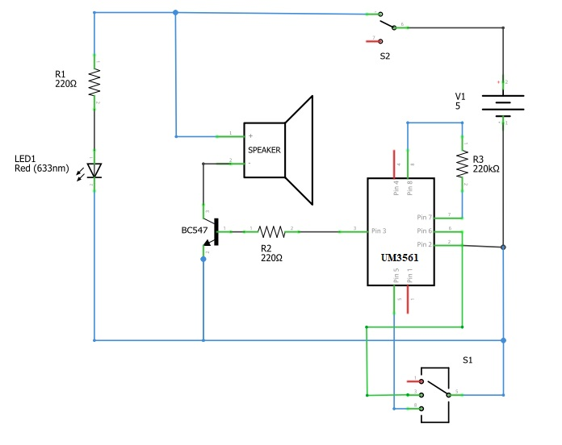

Figure 1: Circuit diagram

**CONCLUSION**

This project aims to design and construct a tune siren using a single IC, offering a compact and cost-effective solution for generating melodies and tunes. The project involves extensive research on IC-based tune sirens, followed by IC selection and component analysis. The circuit design focuses on simplicity and cost-effectiveness, leveraging the IC's capabilities for precise sound generation. User controls enable tune selection and volume adjustment. Through simulation and testing, the project ensures high-quality sound output. The successful construction and testing validate the tune siren's functionality. Overall, this project provides a practical and customizable solution for various applications, enhancing safety and communication.